**Lab Exercise 3–Provisioning an EC2 Instance on AWS**

Prerequisites: Terraform Installed: Make sure you have Terraform installed on your machine. Follow the official installation guide if needed.

AWS Credentials: Ensure you have AWS credentials (Access Key ID and Secret Access Key) configured. You can set them up using the AWS CLI or by setting environment variables.

1. Create a new Directory

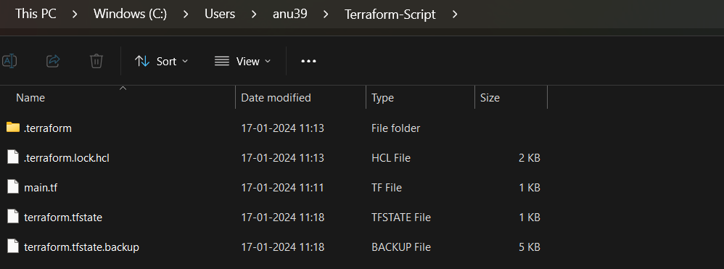

1. Create IAM User

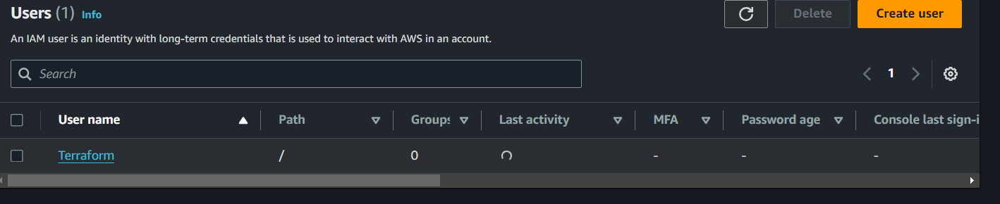

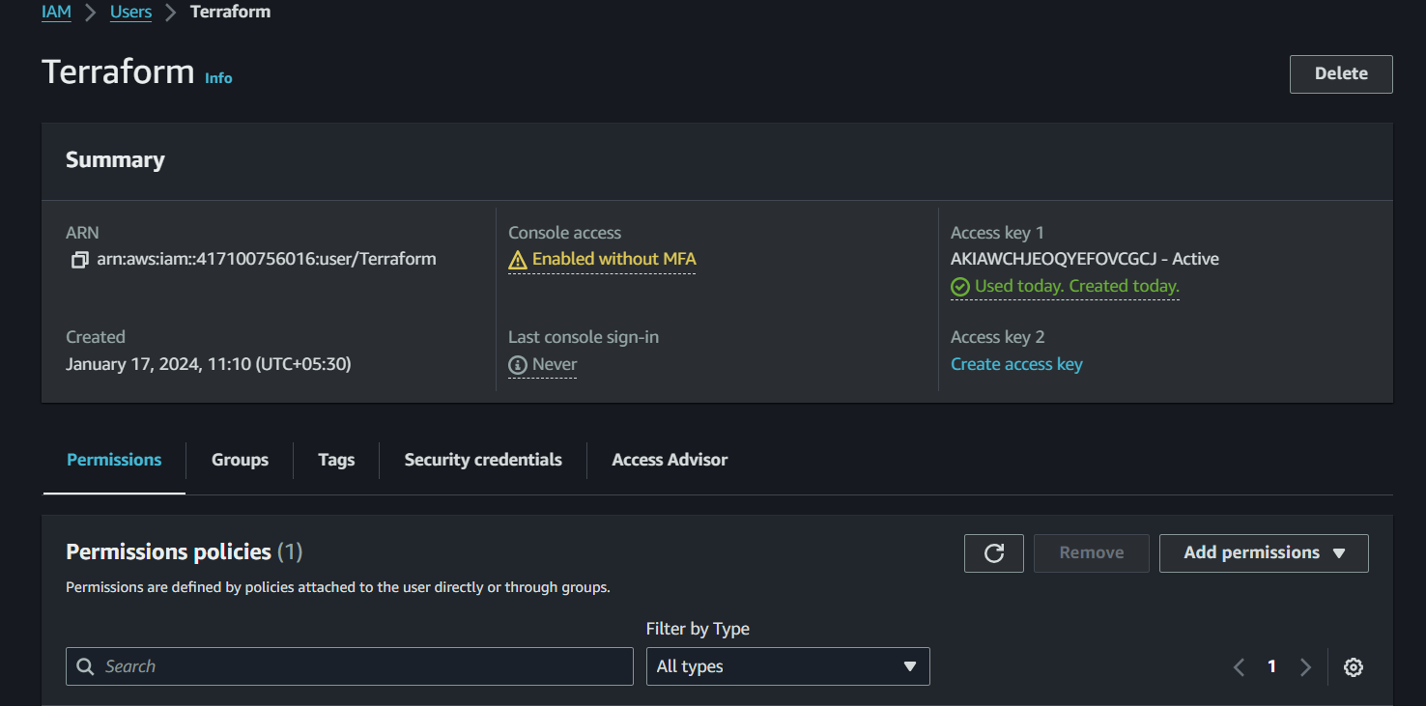

1. Create Terraform Configuration File (main.tf)

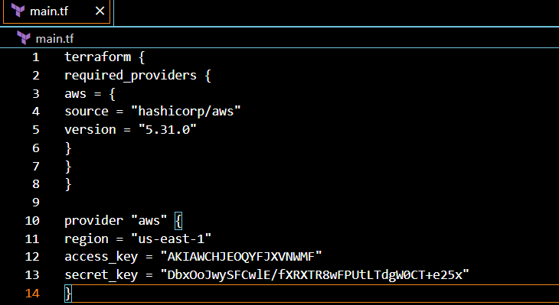

1. Initialize Terraform:

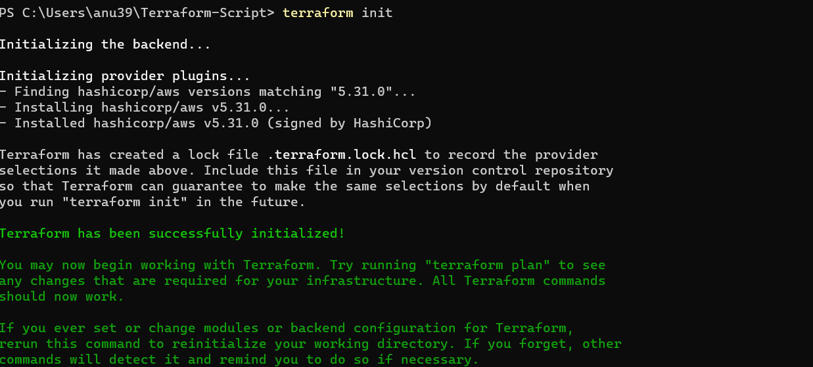

1. Create Terraform Configuration File for EC2 instance (instance.tf):

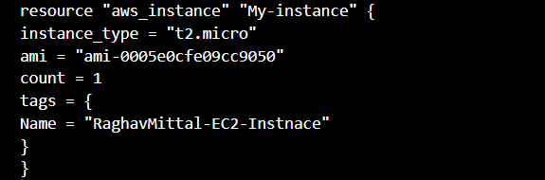

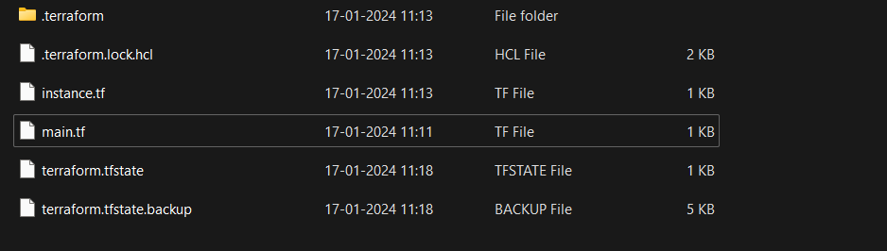

1. Review Plan:

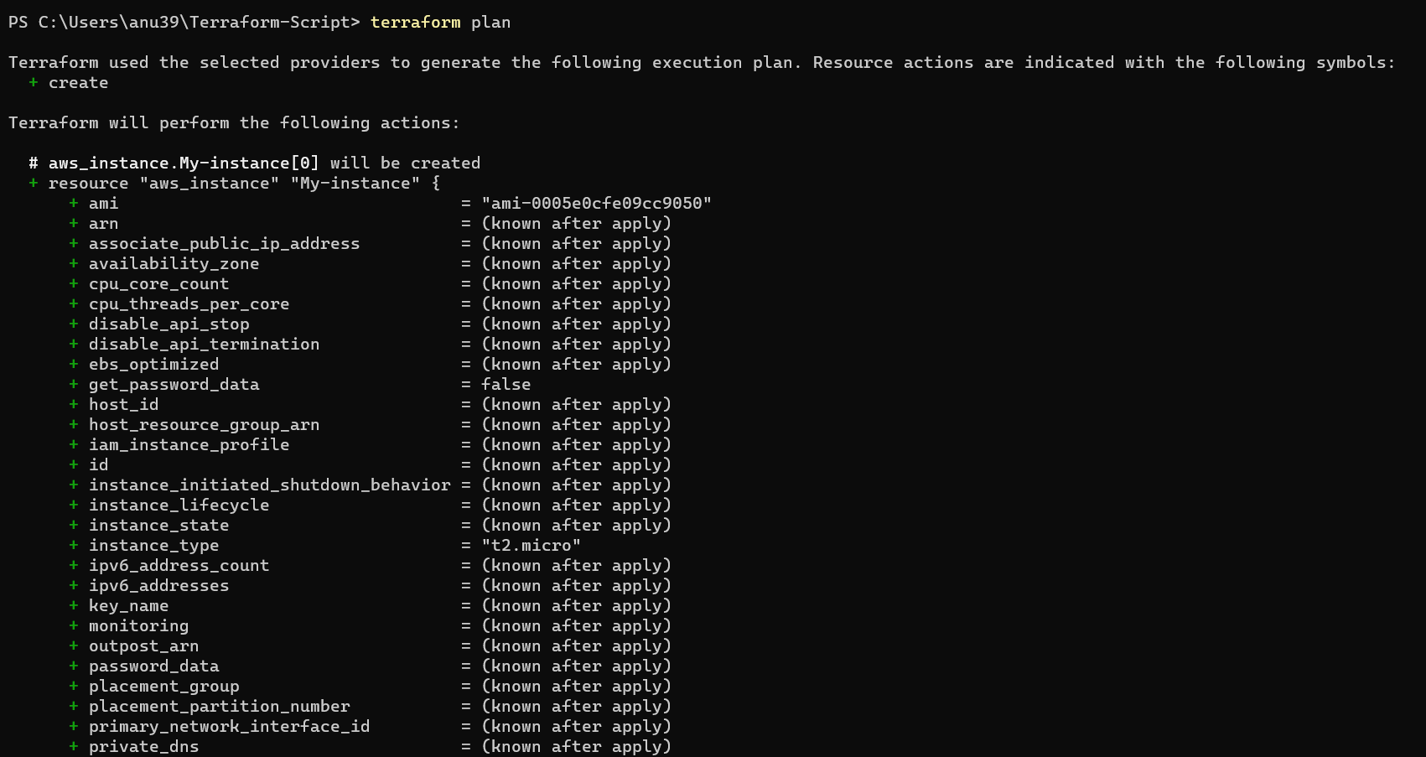

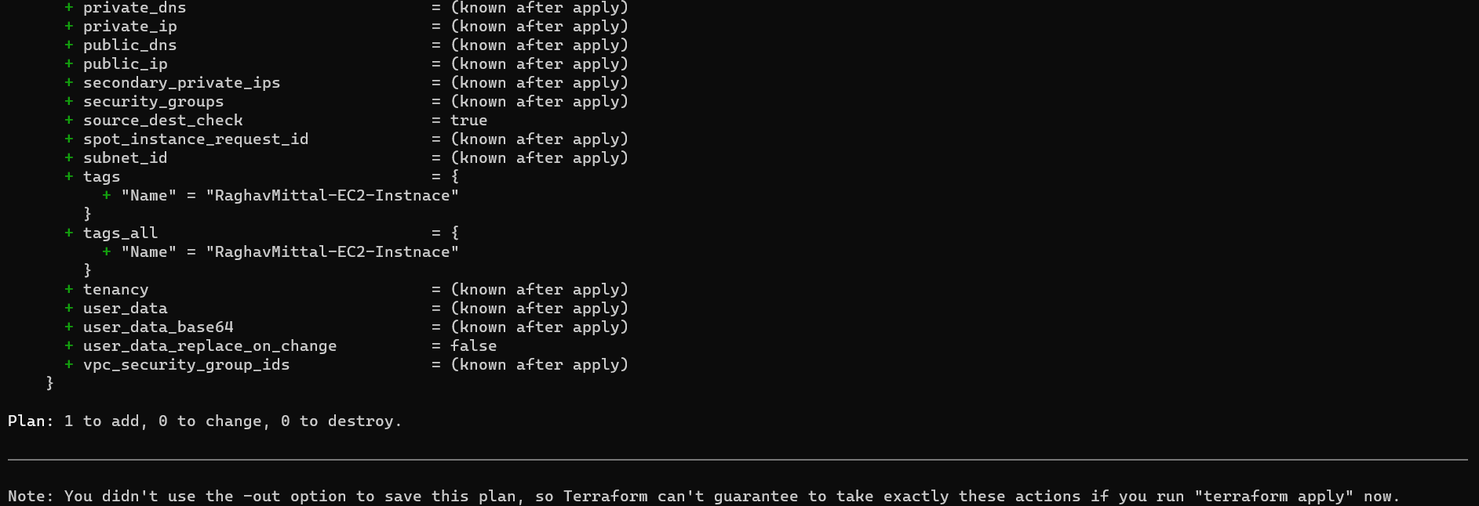

1. Apply Changes:

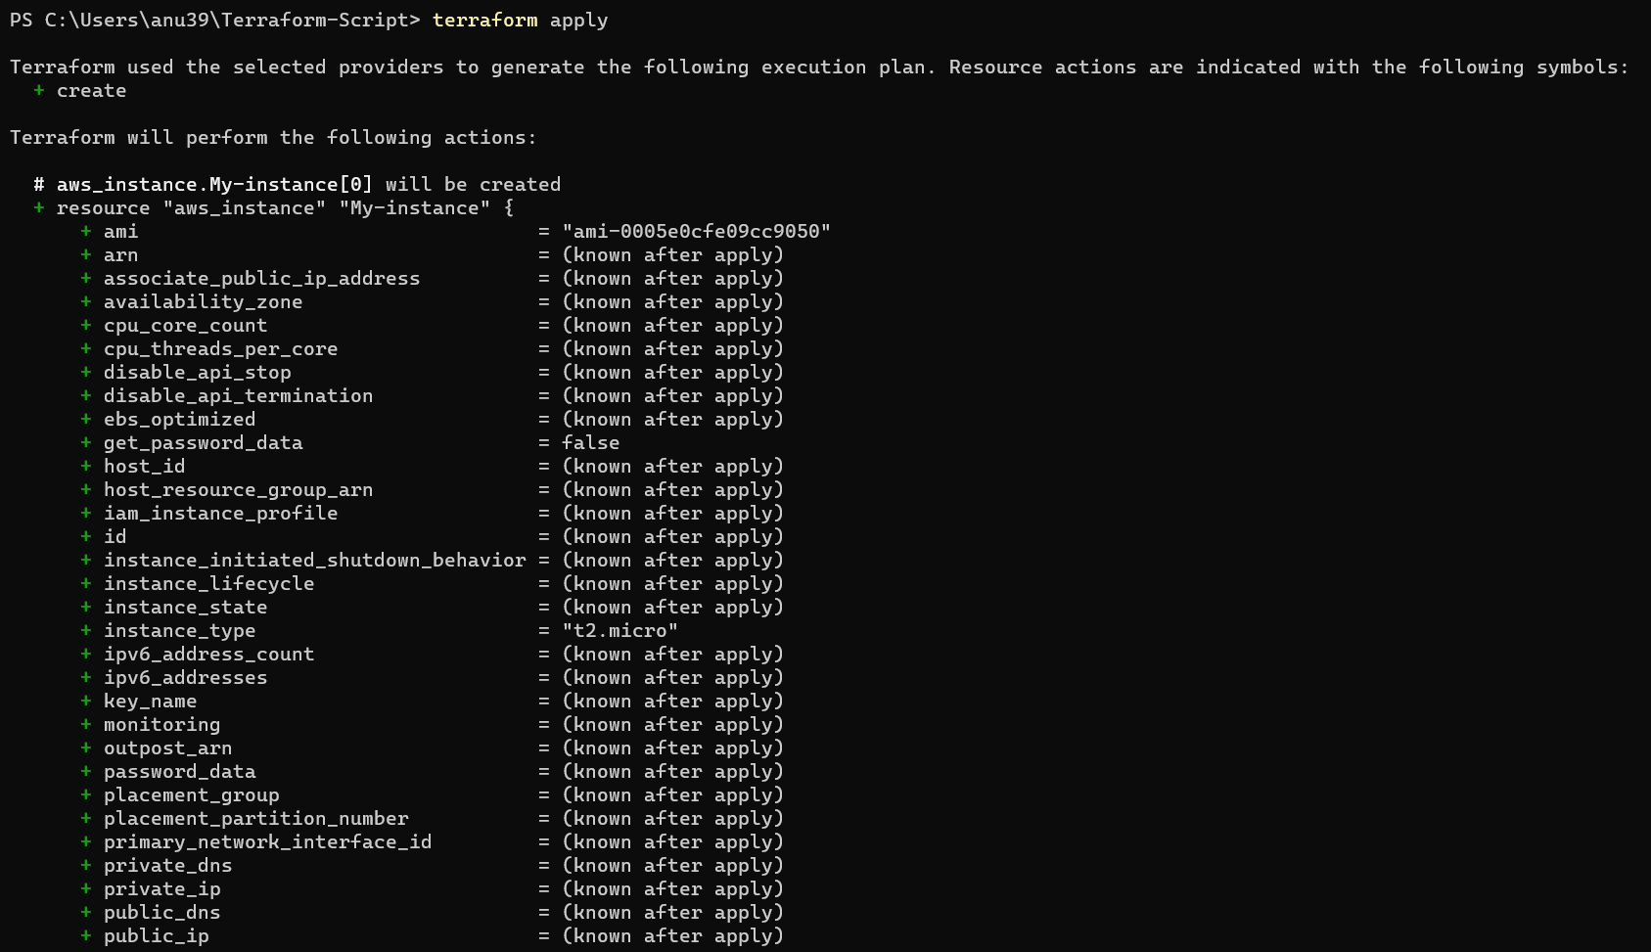

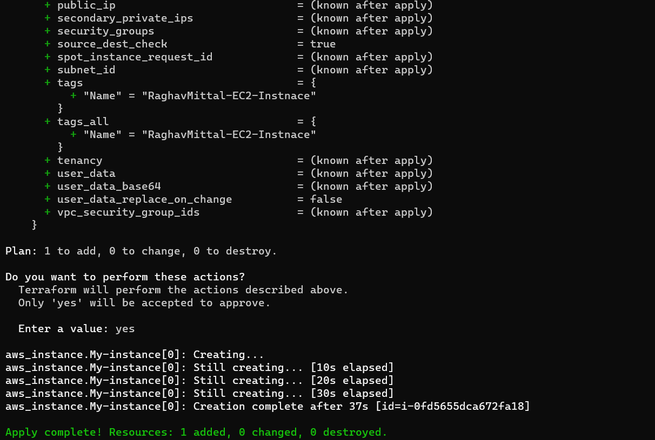

1. Verify the Resources and Connect to Instance:

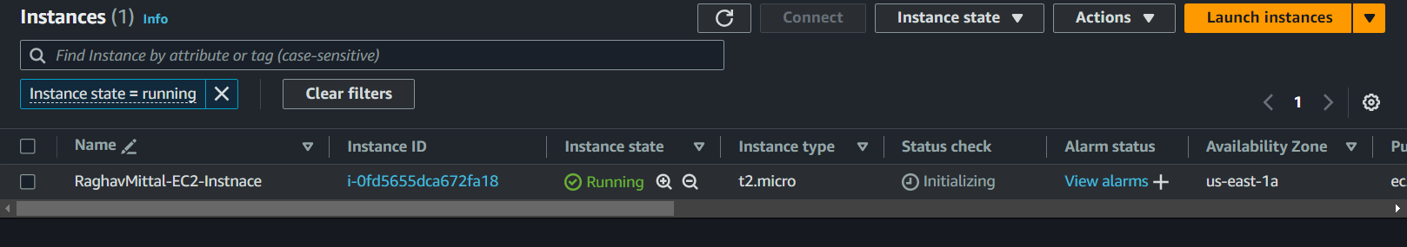

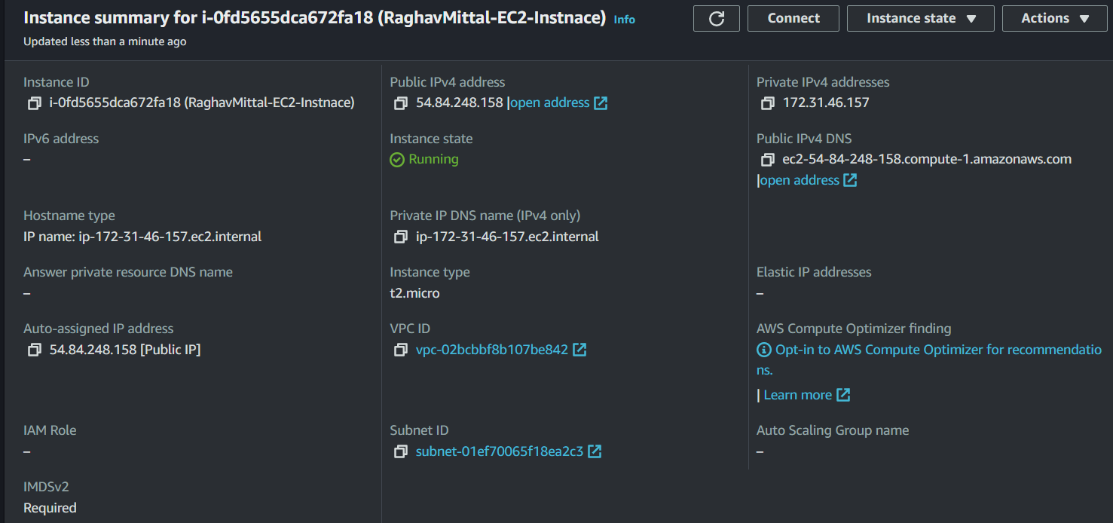



1. Cleanup the Resources:

